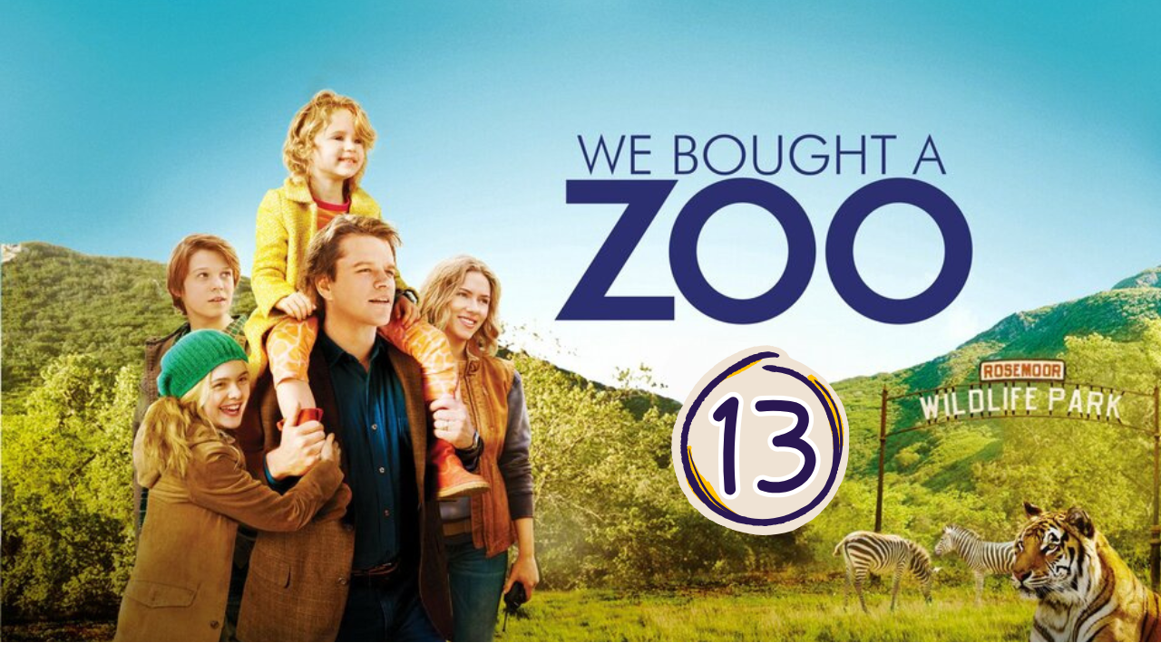
“We Bought a ZOO” (Scene 13)

Work on Scene 01

- Scene summary:

In this scene we see, Mr. Mee watching helplessly Spare when his son comes and a discussion starts. Everyone empties their heart and recognizes their mistakes ending up being reconcile. Mr. Mee explains his son that if he takes only twenty seconds to do what he wants without being afraid or shy, all the problems will be resolved and only great things can happen.
After this we can see Mr. Mee giving his approval to call the vet for Spar so he can die in peace.

- Scene Discussion & Analysis:

- Q01: What happened to Spar? and why was Benjamin sad, while Kelly was happy about it?
Spar is really sick and Kelly wanted to call the vet for spar to kill him in peace while Benjamin didn’t want but he had to do it.
- Q02: Did his son Dylan warm up to him eventually?
- Yes , he did
Q03: Based on their conversation and your own understanding ... why didn’t they use to talk to each other in a friendly way before?
Benjamin and Dylan couldn’t talk to each other in a friendly way before because they had troubles listening to each other . In the previous argument , Benjamin succeeded to explain to his son that he cares about him and he does everything he can so that he and his sister are happy regardless the mistakes he does . Besides, given the current situation in which the zoo is about to lose Spar , they need each other to face this sad moment . For the first time they opened up and expressed their feeling towards each other and towards everything.
- Q04: Watch the scene carefully and name all the 3 animals that appear in it?
The kangaroo
The tiger
the griffon vulture
- Q05: What is Benjamin’s 20-seconds rule? Can you explain it!?
Benjamin’s 20 seconds rule is to take this short moment to feel afraid , worried embraced to do something you want and then everything is going to be ok . He was trying to teach his son to not let those feels stop him from living life. He told him 20 seconds of insane bravery can change your life .
- Q06: Did Dylan also care about Spar?? Support your answer from the scene!
- Dylan also cared about Spar because Benjamin found in his room a drawing of him he drew.
Q07: What is your impression on the scene? (everyone must answer this)
The scene is positive and touching as we see for the first time Benjamin and Dylan talking as friends. The conversation between them was really deep and lovely in which Benjamin taught his son a life time lesson that was inspiring . He told him to be brave in life regardless the feelings he feels. We sense confusion and helpless when Benjamin decided to give the permission to kill Spar . Overall , the scene shows us that no matter how life can get , everything is going to be ok if we are strong together .

- Acquired Vocabulary (OPTIONAL):

- “embarrassing” (adj):
- Example in a sentence:
“ The Parents are in an embarrassing situation because their kids wanted to buy the toys so badly “

- “out to the sticks”:
- Example in a sentence:
“ We went out to the sticks for a peaceful vacation “

Additional Exercise (Optional)

Task: Transcribe sentences from the scene.

► Transcribe Sentence 01
- I like you when you talk ,you know ? Sometimes all you need is 20 seconds of insane courage . Just literally 20 seconds of just embarrassing bravery and I promise you something great will come of it .
► Transcribe Sentence 02
- Why don’t we just tell each other what we wish the other guy would say ?

